TX-NZ12 Mobile Telecom Unicom Mobile Phone WIFI Signal Jammer

I. Characteristics
1. Wide coverage of 100-200 square meters (-75dBm, indoor transparent environment, depending on the distance of surrounding base stations)
2. High power 60W (single 5W) effectively blocks 2G 3G 4G 5G mobile phone signals and WIFI signals from three networks
3. Equipped with a precision voltage stabilizing circuit, it can be used normally even in cases of significant voltage fluctuations
4. Original chips and circuit boards ensure efficient, stable performance and ultra long lifespan
5. Engineering and durable shell: wear-resistant and heat-resistant
6. Convective ventilation holes and built-in high-efficiency heat dissipation fins and fans prevent local heat accumulation and efficient heat removal
7. Simple appearance, small size, and less space occupation
8. Easy and convenient installation
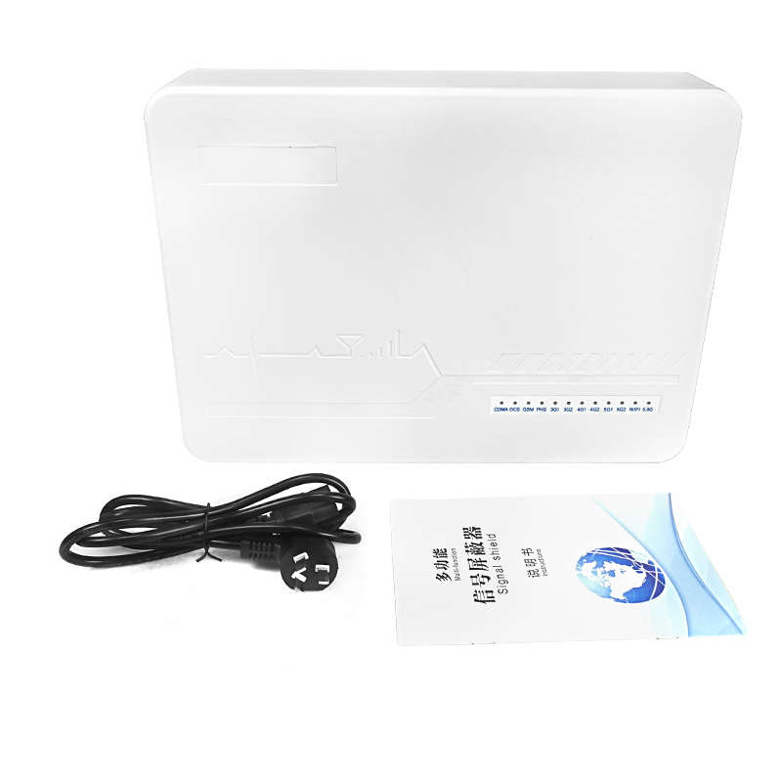
II.Parameter
Technical standards (transmission power) | Working Frequency | Average output power
2G-CDMA | 870-880 MHz | 5W
2G-GSM | 925-960 MHz | 5W
2G-DCS | 1805-1880 MHz | 5W
SVA 5G | 698-806MHZ | 5W
4G-FDD-LTE | 1880-1920 MHz | 5W
3G-TD-LTE | 2010-2170 MHz | 5W
4G-TD-LTE &WIFI | 2300-2500 MHz | 5W
WIFI 5.8G | 5725-5850 MHz | 5W
4G-TD-LTE | 2500-2700 MHz | 5W
5G-FDD-LTE | 3400-3600 MHz | 5W
5G-TD-LTE | 4800-4900 MHz | 5W
WIFI 5.1G | 5150-5350MHZ | 5W
Host size | 383*284*73mm
Host weight | 2.5kg
Ambient temperature | -40℃~65℃
Relative humidity | 35~85%
Power consumption | ≤240W
Power input | AC 160V~240V
Power ouput | DC 24V/12A
Installation height | 1.8m~2.5m
Installation environment | Indoor

III.Packaging List

Jammer host * 1
AC power cord * 1

VI.Precaution
1. The effective shielding range of mobile phone signal blockers varies depending on the usage site. This is closely related to the signal field strength on site. The shielding range of mobile phones with different standards may not necessarily be the same on the same site;
2. The factors that affect the shielding range include but are not limited to: distance relative to the base station, orientation, presence of obstacles, wall materials of on-site buildings, installation height of mobile phone shields, installation specifications, etc;
3. After prolonged operation, the surface temperature of the shield is about 40-55 ℃, which is normal. If the surface temperature is too high, please turn off the power and try to contact your local dealer or agent;
4. The normal recommended installation height is 1.8-2.5 meters, and it is recommended to install it in a location without obstacles between the target shielding area and the target.
During use, in order to avoid possible interference with some electronic devices, it is advisable to maintain a distance of 1-2 meters or more from the following common devices: audio, wireless microphones, radios, computers, televisions, Wi Fi routers, etc

