12 channel high-power Mobile phone signal WiFi Jammer

Product Description
Model: TX-CM12
With the development of the times, the Mobile phone signal is getting stronger and stronger, and the Mobile phone signal has also increased from the original 2g3g 4g to 2g3g 4g5g, and the frequency of Mobile phone signal is increasing.The role of previous interference devices has become increasingly limited. So we are also constantly innovating. This product can support 12 different signal frequency bands and simultaneously interfere with signals such as mobile phones and WiFi.And the maximum power of a single circuit can be 5W, effectively expanding the operating range.And this is a built-in antenna type.

Product Features
1. High power design, with a single channel power of 5-10W and a total maximum total power of 80W
2. ABS shell, beautiful, durable, and friction resistant
3. Built in antenna design, easy to use and space saving, convenient and fast
4. The cooling holes are distributed on the left and right sides to form air convection, which can form a good ventilation and cooling system with high-power Computer fan
5. Conventional 12 channels, capable of accommodating up to 16 signal frequency bands. The frequency bands support customization, allowing for as much signal coverage as possible, or single channel multi frequency bands, doubling the effectiveness
6. One button switch, easy to use, supports 24-hour uninterrupted operation
Suitable for various occasions such as schools, meeting rooms, etc

Product parameters
The signal frequency band supports customization. The following frequencies are regular shipment frequencies (Mobile phone signal 2345g+wifi)
Signal | Frequency |  | Output power | power parameters
CDMA | 869-894MHz |  | 37dBm | 37dBm/30KHz(min)
/GSM | 925-960MHz |  | 37dBm | 37dBm/30KHz(min)
TD | 2010-2025MHz |  | 37dBm | 37dBm/30KHz(min)
DCS/PHS | 1805-1920MHz |  | 37dBm | 37dBm/30KHz(min)
3G | 2110-2170MHz |  | 37dBm | 37dBm/30KHz(min)
4G1 | 2300-2390MHz |  | 37dBm | 37dBm/30KHz(min)
4G/5G | 2510-2690MHz |  | 37dBm | 37dBm/30KHz(min)
WIFI | 2400-2500MHz |  | 37dBm | 37dBm/30KHz(min)
5GWIFI | 5725-5850MHz |  | 35dBm | 37dBm/30KHz(min)
5G | 3400-3600MHz |  | 35dBm | 37dBm/30KHz(min)
5G | 3600-3800MHz |  | 35dBm | 37dBm/30KHz(min)
Power supply： AC110~240V 50/60MHz  DC24V/10A |  |  | Jamming range: 10-50 M （depends on real environment）
power dissipation: 80W |  | Weight 3.1Kg | Size：36*33*10 cm

Application:
1. Prevent illegal and criminal activities through mobile phones, such as prisons, Detention center, labor camps, public security, courts, procuratorates and other judicial places
2. Prevent the leakage of important information or trade secrets, such as real estate transaction sites, commercial conference rooms, military and important confidential places, party and government agencies, administrative institutions, major criminal case sites, law enforcement sites, and important security sites
3. Prevent accidents caused by mobile phones or WiFi signals, such as gas stations, chemical plants, oil depots, special goods warehouses, and other places where hazardous, flammable, and explosive materials are stored and produced
4. Prevent noise and noise from mobile phones, phones, and other activities. In places that need to be kept quiet, such as libraries, cinemas, theaters, concert halls, memorials, auditoriums, churches, etc
5. Prevent candidates from cheating and maintain fairness, justice, and order in school examination halls and various competitions
6. Prevent factory and company personnel from playing with mobile phones during work hours, effectively avoiding workshop work accidents caused by playing with mobile phones, and improving work efficiency, such as in textile factories
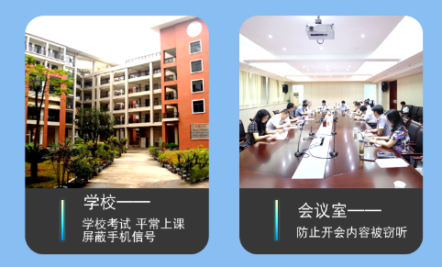
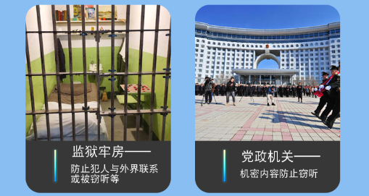
Instructions for use:
1. The built-in unit does not require the installation of an antenna, but directly connects to the power supply in the area that needs interference and turns on the switch
2. The working mode of this machine is controlled by the power supply.
Default power-on and power-off: When the power is turned on and the device starts, the device emits the maximum power; Turn off the power and the device stops working.
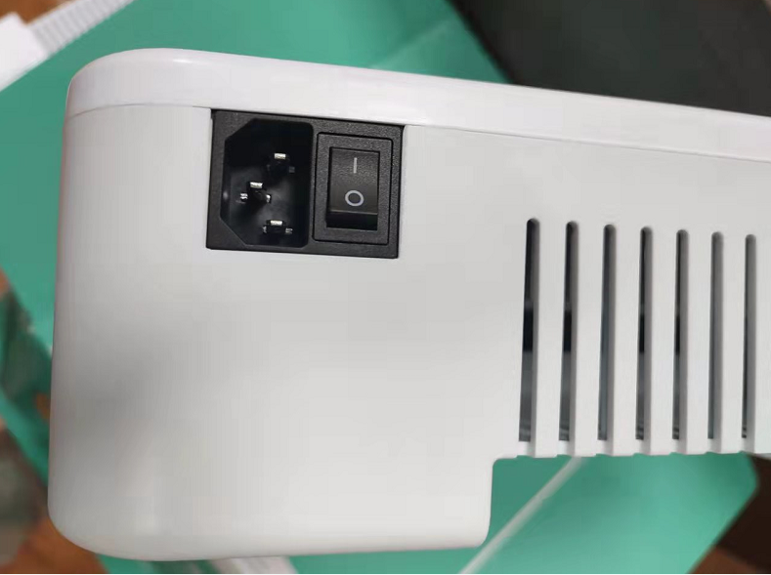

Packaging List

Packing list
1. Jammer* 1
2. Power wire * 1
Color box or kraft paper box
