H8K Desktop Portable Signal Jammer

- Feature
- Large shield coverage up to 100-150 sqm (-75dBm, depends on real signal environment and distance from base station)
- High output power each channel 3-5W, effectively shield 2G 3G 4G 5G phone signal (WIFI customized)
- It can shield all band at same time or choose to shield each band as need
- Precise regulated power supply to ensure smooth use even under large voltage flunctuation
- Original IC chip and printed circuit design, to assure stable use and long life span
- Engineering grade alluminum alloy outshell: Waterproof, Dustproof, Durable, Nice heat dissipation function
- Convection Ventilation Hole and built in thick heat dissipation fin and fan, will efficiently blow heat away fast
- Simple shape, Small Size, Light weight for Space saving
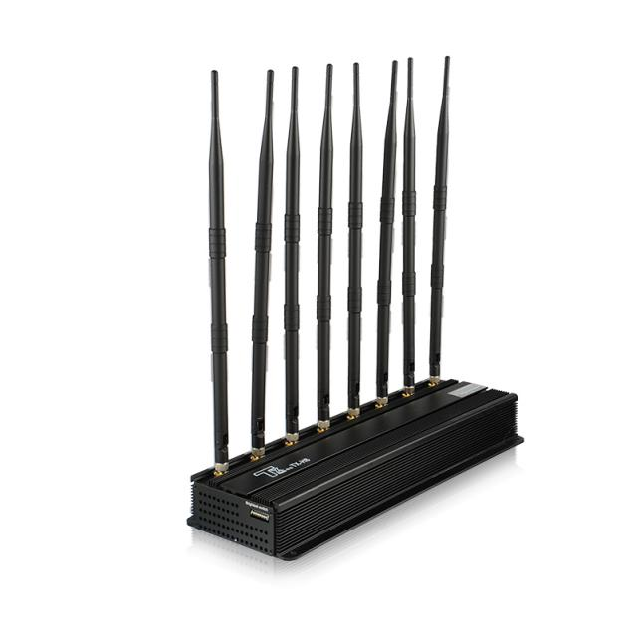
- Easy installation and opeartion
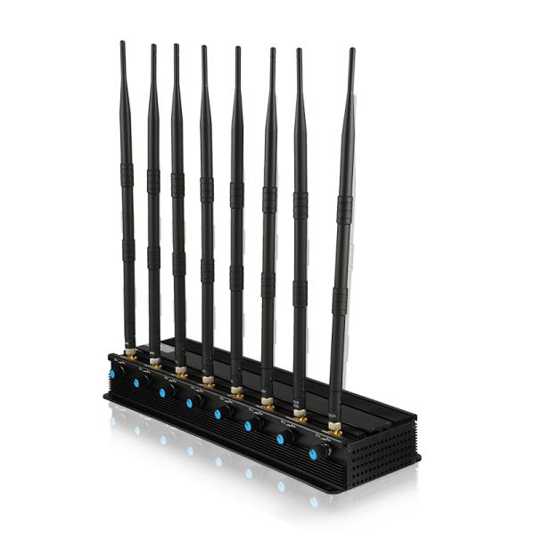

- Specification (Frequency can all be customized)
Band | Name | Frequency | Average Output
1 | LTE 700/800 | 721-821 MHz | 3-5W
2 | 850/900 | 850-960 MHz | 3-5W
3 | 1800/1900 | 1805-1990 MHz | 3-5W
4 | 2100 | 2110-2170 MHz | 3-5W
5 | 2600 | 2500-2690 MHz | 3-5W
6 | WIFI 2.4G | 2400-2500 MHz | 3-5W
7 | WiFi5.8G | 5725-5850 MHz | 3-5W
8 | GPSL1 | 1560-1620 MHz | 3-5W
Size | 310*110*40mm(Antenna is 38CM)
Weight | 3.0kg
Work Temperature | -40℃~55℃
Relative Humidity | 30~95%
Power Consumption | 60W
Power Input | AC160~240,DC12V-24V
Power Output | DC 24V/12A
Installtion Height | 1.8m~2.5m (Suggest)
Installtion Place | Indoor (Suggest)

- Packing List
1*Jammer
8*Antenna
1*AC adapter
1* Car Charger
1*user manual

- Details Photo
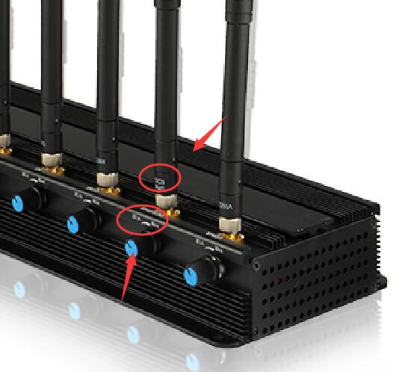
Connect the antenna by signs on jammer and antenna

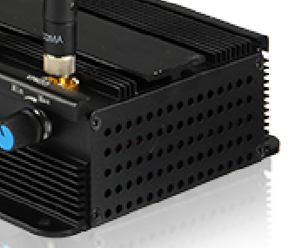
Convection ventilation hole and Built in large fans help blow heat away fast

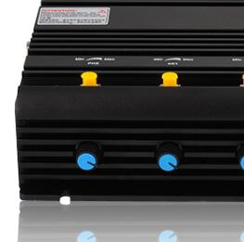
Single button control to switch on/off specific frequency

- Attention
- The factors influences the effective shield range including the signal strength around, base station distance, barriers, installation height, installaiton regulation, etc.
- The antenna must be connected to the jammer by signs relatively; please don’t turn on power until all antenas connected well
- A certain rise of jammer temperature is normal
- Please try to be sure there ar no barriers bettween jammer and target shielding place

- After Sales Service
- If no artificial damage, we offer one month free

